A Project Report On

**" Let’s Clean (E-waste Management) "**

Submitted To

**Savitribai Phule Pune University**

In partial fulfilment of the degree of

**Bachelor of Business Administration**



By

**Pratyush Majumdar**

**and**

**Mahendra Jat**

Seat No: **15429**

**and**

Seat No: **15422**

BBA-CA

Semester V

Under the guidance of

**Mrs. Padma Nene**

Research Guide

MES Garware College of Commerce, Karve Road, Pune 411004 (2022-2023)



Maharashtra Education society’s

**GARWARE COLLEGE OF COMMERCE, AUTONOMOUS**

Karve Road, Deccan Gymkhana,

Pune - 411044

**CERTIFICATE**

This is to certify that Mr. **Pratyush Prakash Majumdar** and Mr. **Mahendra Jat** Roll Number **15429** and **15422** University Exam Seat Number--------- Student of BBA-CA Semester-**V** have successfully completed the project work in specialization subject **HTML, CSS, JS** entitled as **Let’s Clean (E-waste Management)**  a partial fulfillment of the degree of Bachelors of Business Administration Computer Application as per the syllabus of the University of Pune, Year 2023-2024.

I further clarify that; the work has been carried out under my supervision.

Project Guide BBA-CA Coordinator Officiating Principal

Internal Examiner External Examiner

**CONTENT**

|  |
| --- |
| 1. Introduction  * Introduction of System * Objective of System |
| 1. Requirements   • Hardware & Software Requirement |
| 1. System Design  * Entity Relationship Diagram * Context Level Diagram |
| 1. Website Design  * Homepage * About Anxiety * Symptoms of OCD * Causes of ADHD * Cure for Bipolar Disorder * Contact Us * Take a Quiz * Feedback |
| 1. System Limitations |
| 1. Conclusion |
| 1. References |

**INTRODUCTION OF SYSTEM**

* Mental health determines how you think, feel and act.
* Good mental health is when you feel positive about yourself and cope well with the everyday pressures.
* If you experience issues dealing with everyday problems, it could be a sign of a mental health problem and should be addressed immediately.
* This website basically helps youths and citizens of all age to filter and clarify their thoughts, help them identify their problems and implement various kind of helpful available on this website using various tools and data available.

**OBJECTIVES OF SYSTEM**

* The main objective of this website is to empower and educate people with the information and insight they need to improve their mental health and make healthy changes.
* Providing the principles, patterns and practices needed for personal and mental development.
* Various kind of live interaction provided with professional therapists.
* Goal is to reach out as many people as possible in order to educate and help them about their mind and mental health.

**SYSTEM REQUIREMENT SPECIFICATION**

1. **HARDWARE REQUIREMENT**

* Internet connection or wireless adapter (Wi-Fi)
* Processor: Intel i3
* Memory(RAM): 4GB

1. **SOFTWARE REQUIREMENT**

* Operating System : Windows 10.
* Application Software : HTML, CSS and JavaScript.
* Browser : Google Chrome

**SYSTEM DESIGN**

1. **ENTITY RELATIONSHIP DIAGRAM**

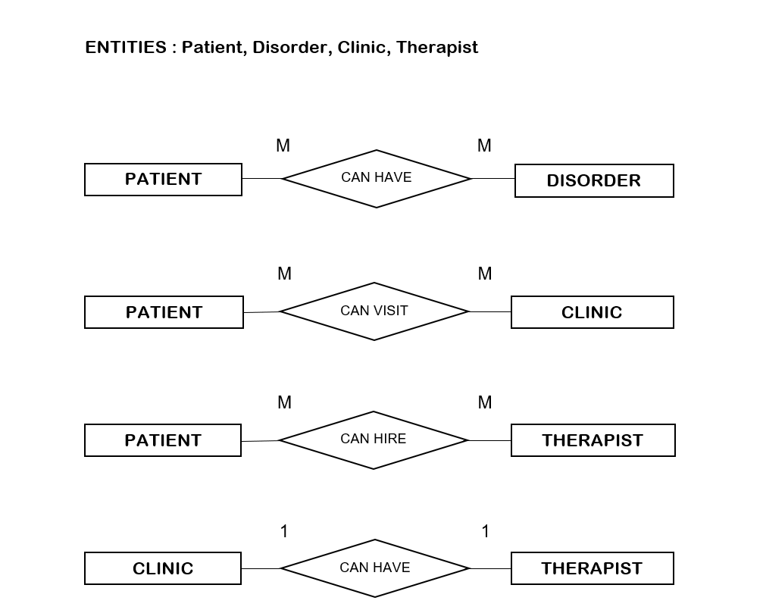

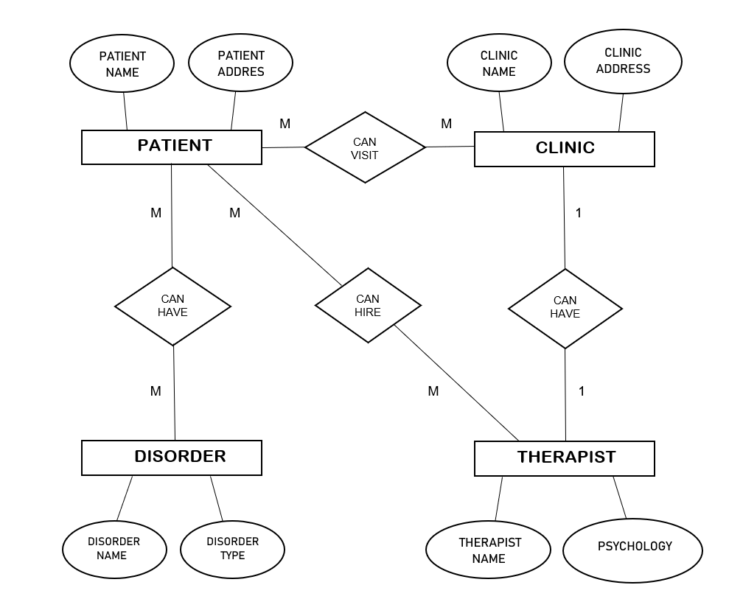

1. **CONTEXT LEVEL DIAGRAM**

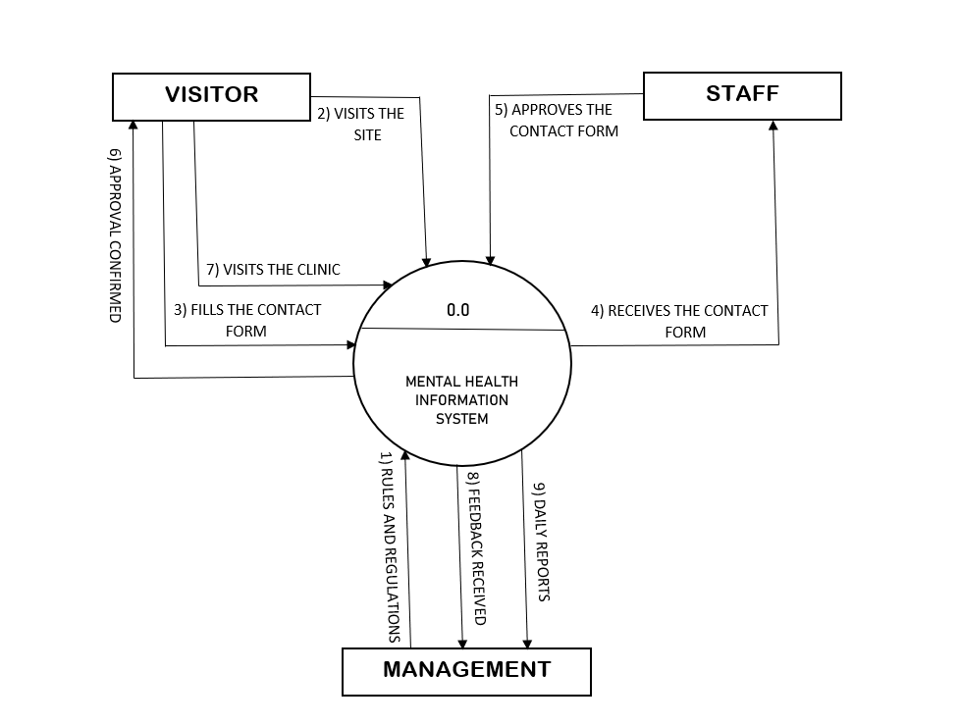

**SNAPSHOTS**

1. **HOMEPAGE**

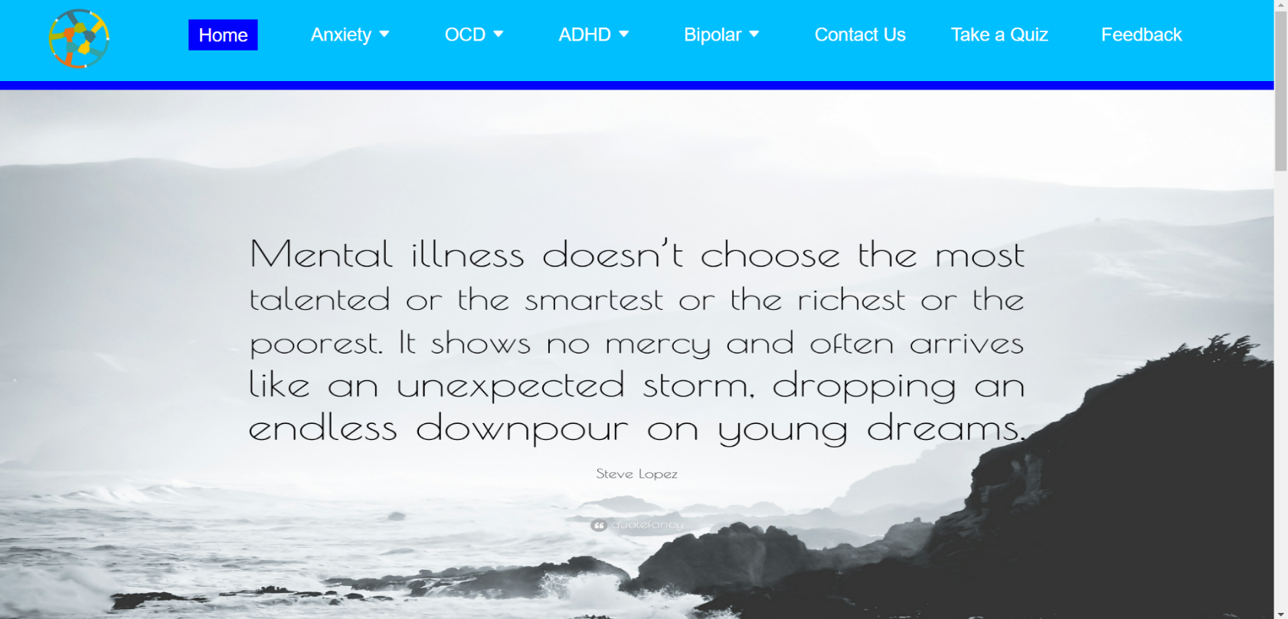

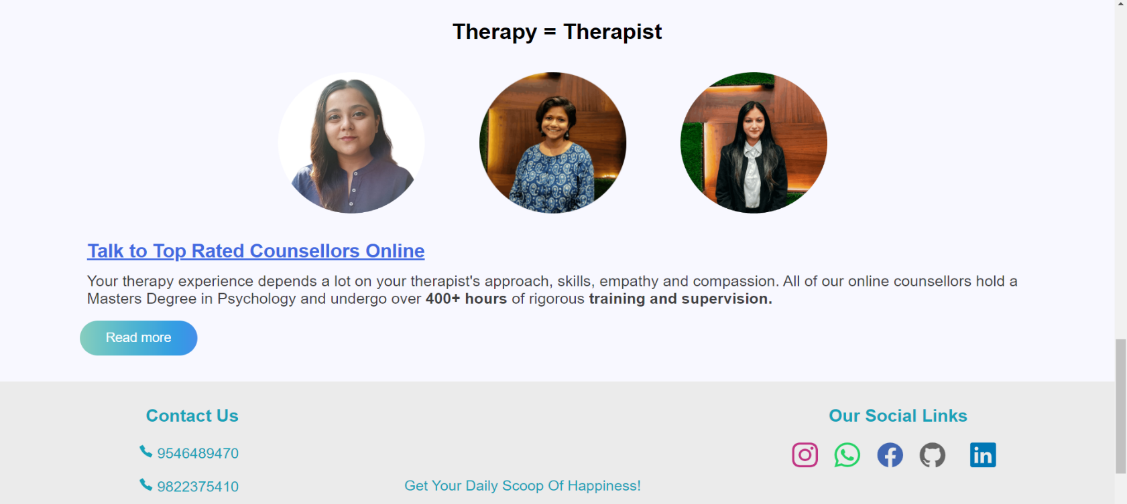

1. **ABOUT ANXIETY**

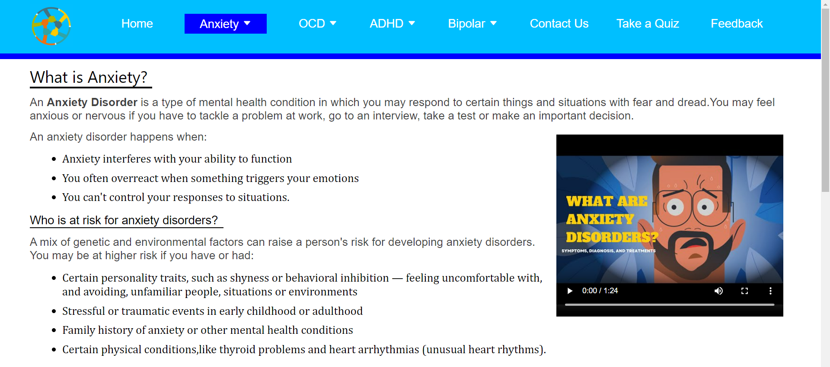

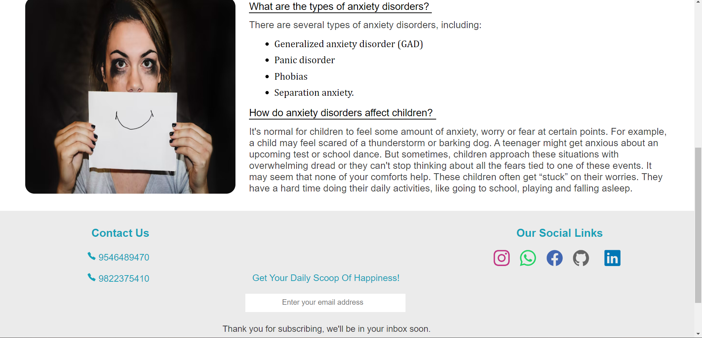

1. **SYMTOMS OF OCD**

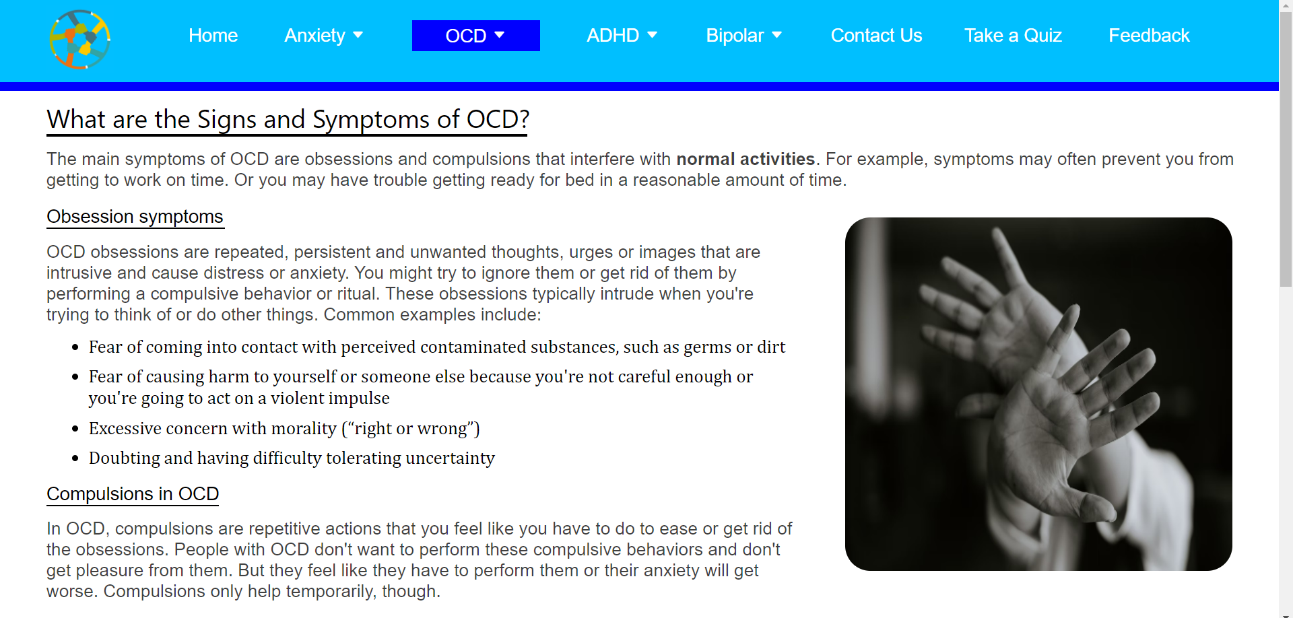

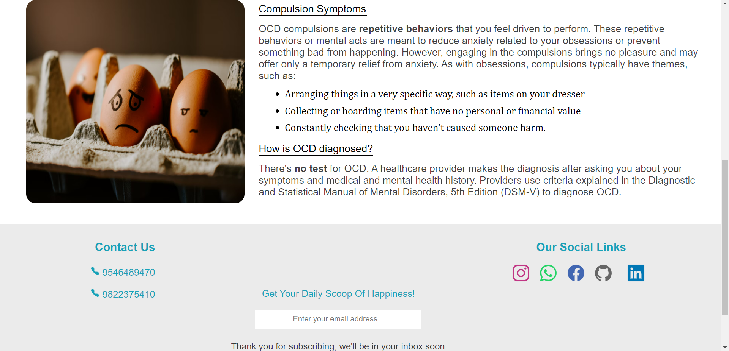

1. **CAUSES OF ADHD**

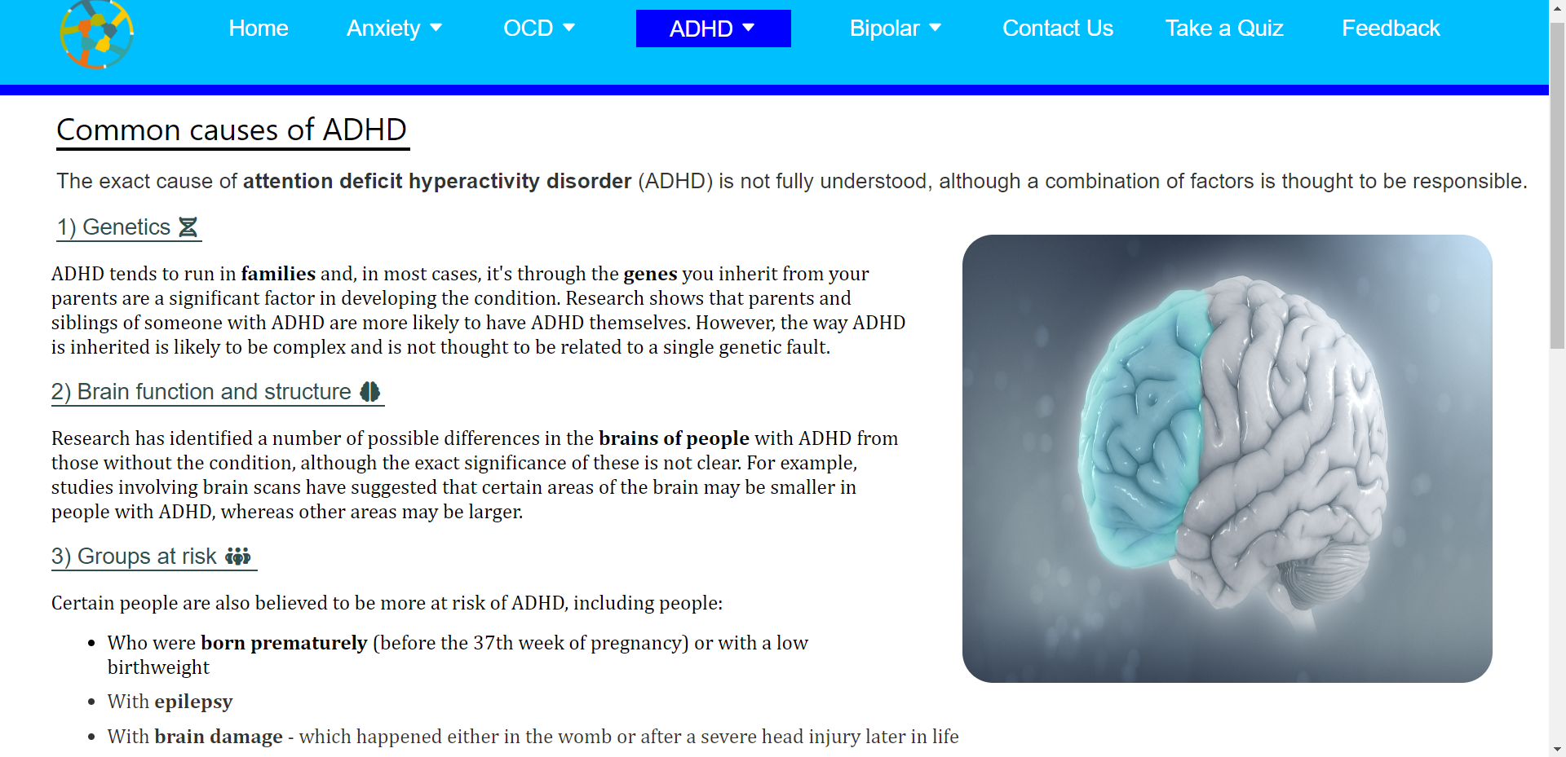

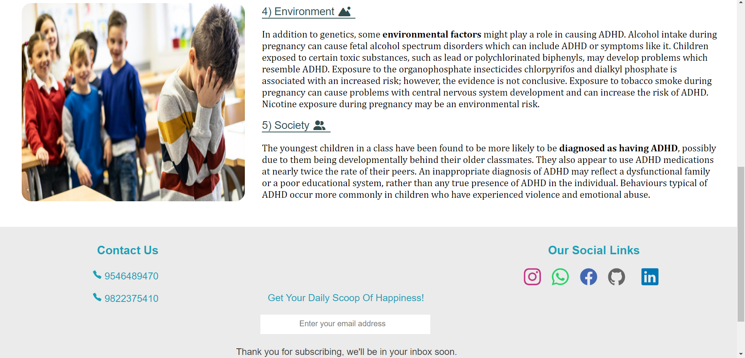

1. **CURE FOR BIPOLAR DISORDER**

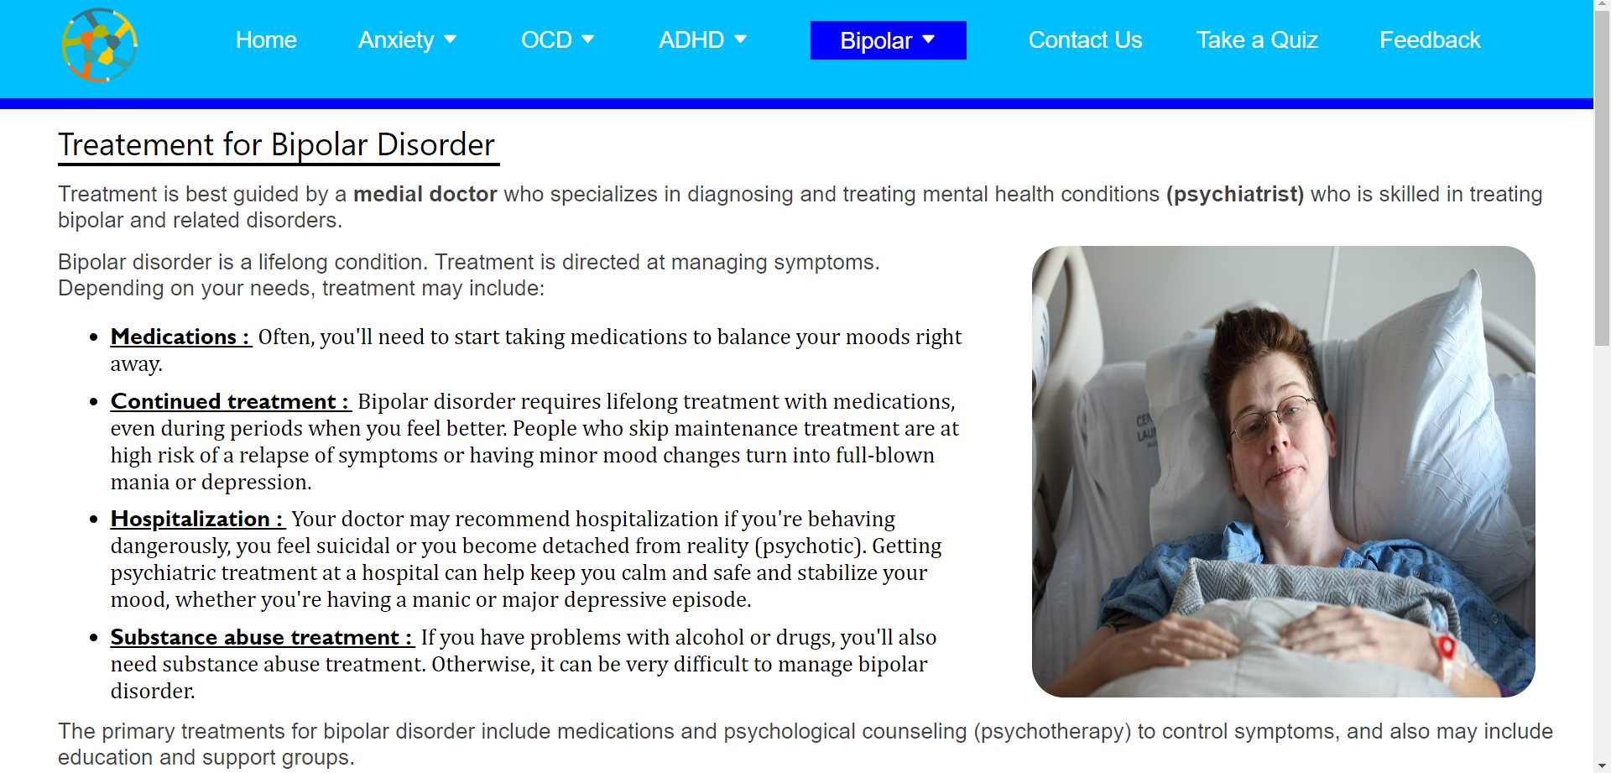

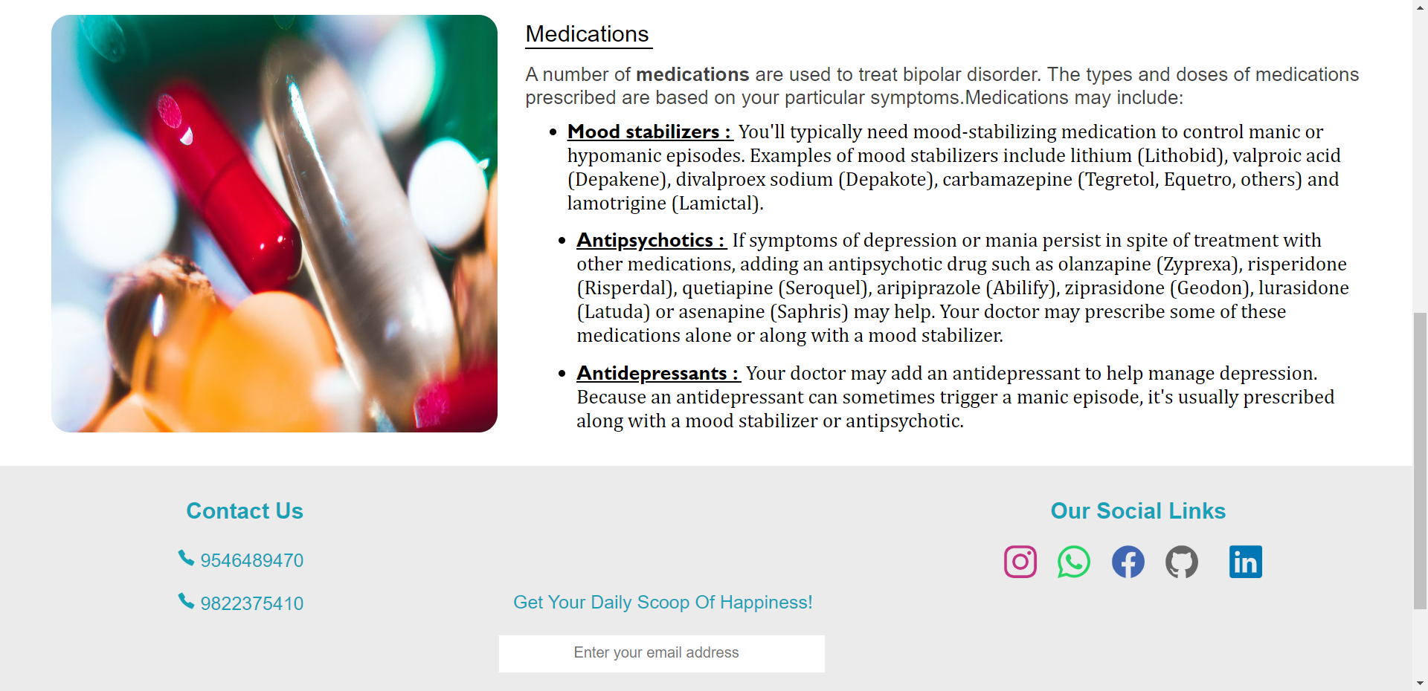

1. **CONTACT US**

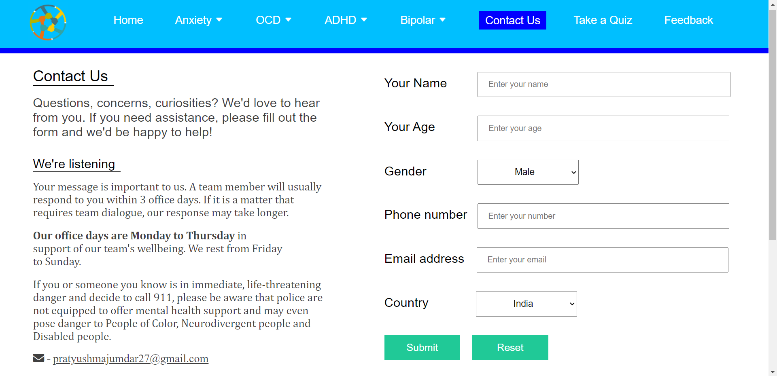

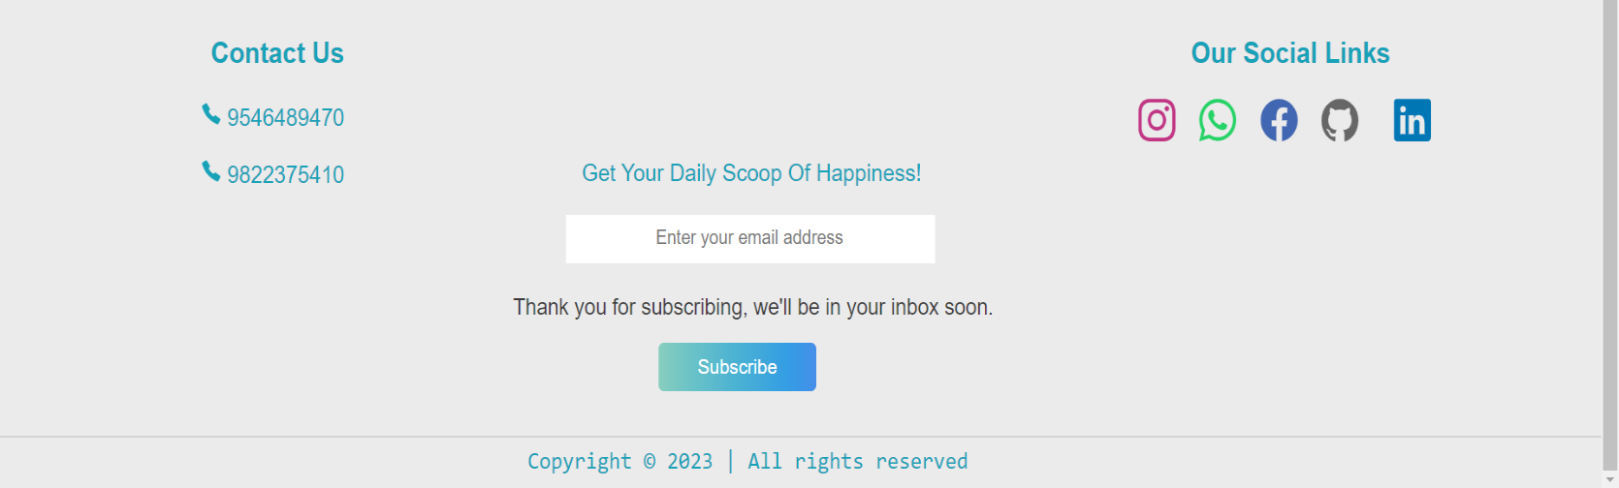

1. **TAKE A QUIZ**

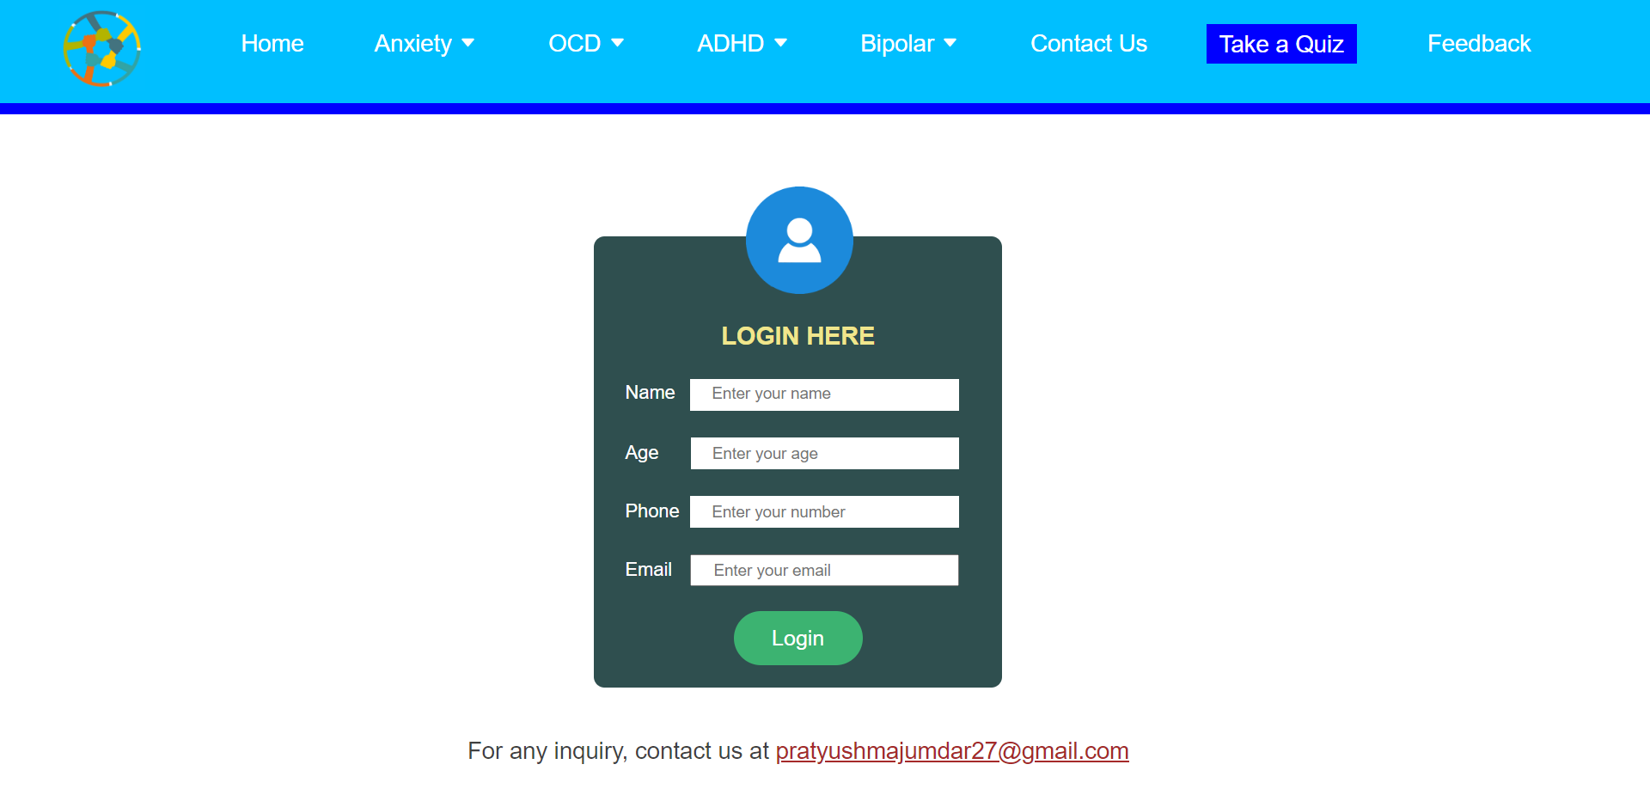

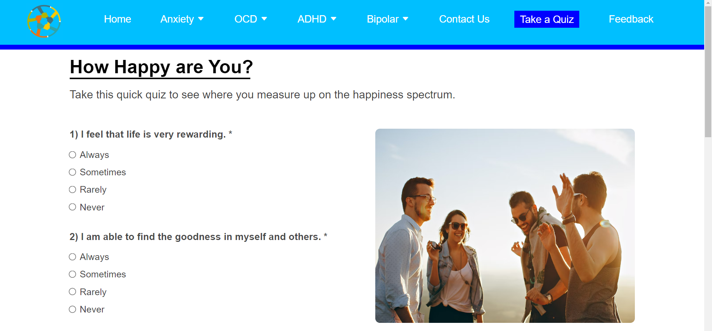

1. **FEEDBACK**

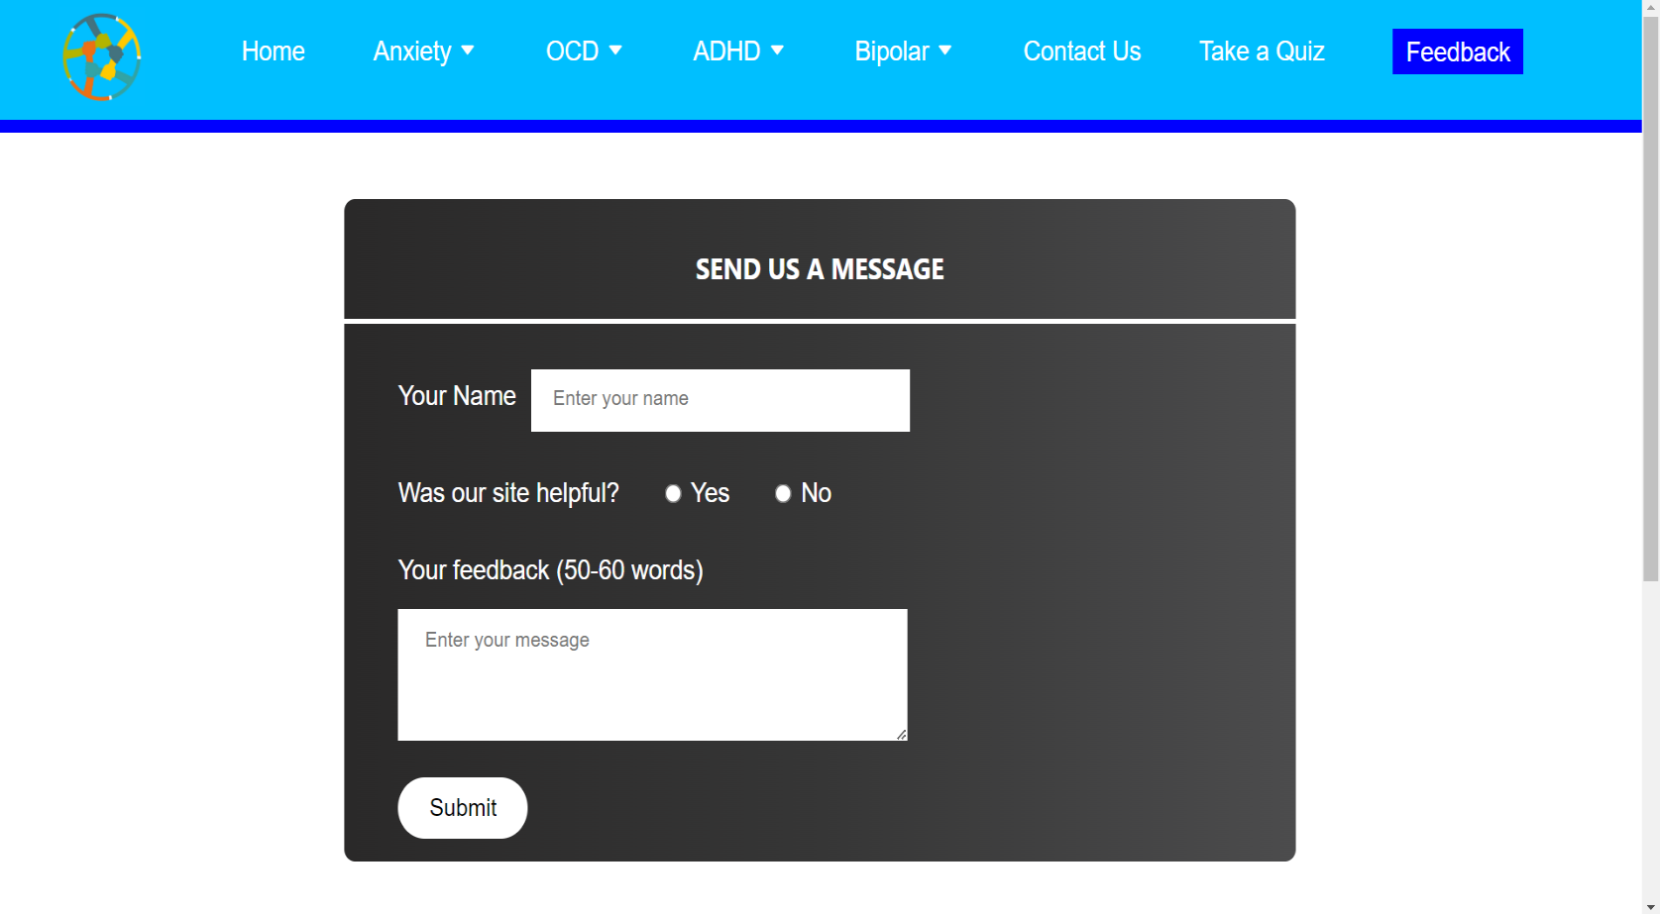

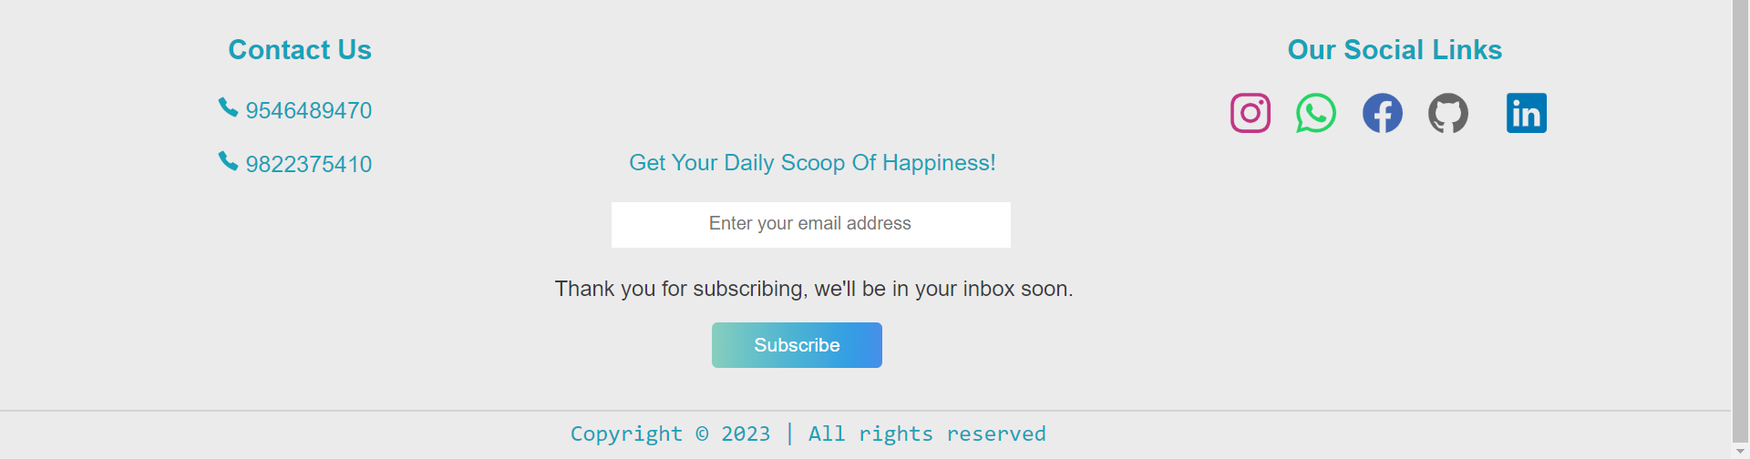

**SYSTEM LIMITATIONS**

* Mental health conditions require careful diagnosis and treatment, which may not be possible through a website.
* Mental health websites may not be accessible to everyone, as not all individuals have access to the internet or may not be aware of the website’s existence.
* Websites may offer information, but may not be able to provide human interaction or emotional support, which can be crucial in times of distress.
* There is a risk that some information on mental health websites may be inaccurate or misleading.

**CONCLUSION**

* The main objective of this website is to empower and educate people with the information and insight they need to improve their mental health and make healthy changes.
* We assessed whether an intervention based on acceptance and commitment therapy and mindfulness was successful in promoting positive mental health by enhancing psychological flexibility.

**REFERENCES**

1. [https](https://www.farmingindia.in/) ://www.betterlyf.com